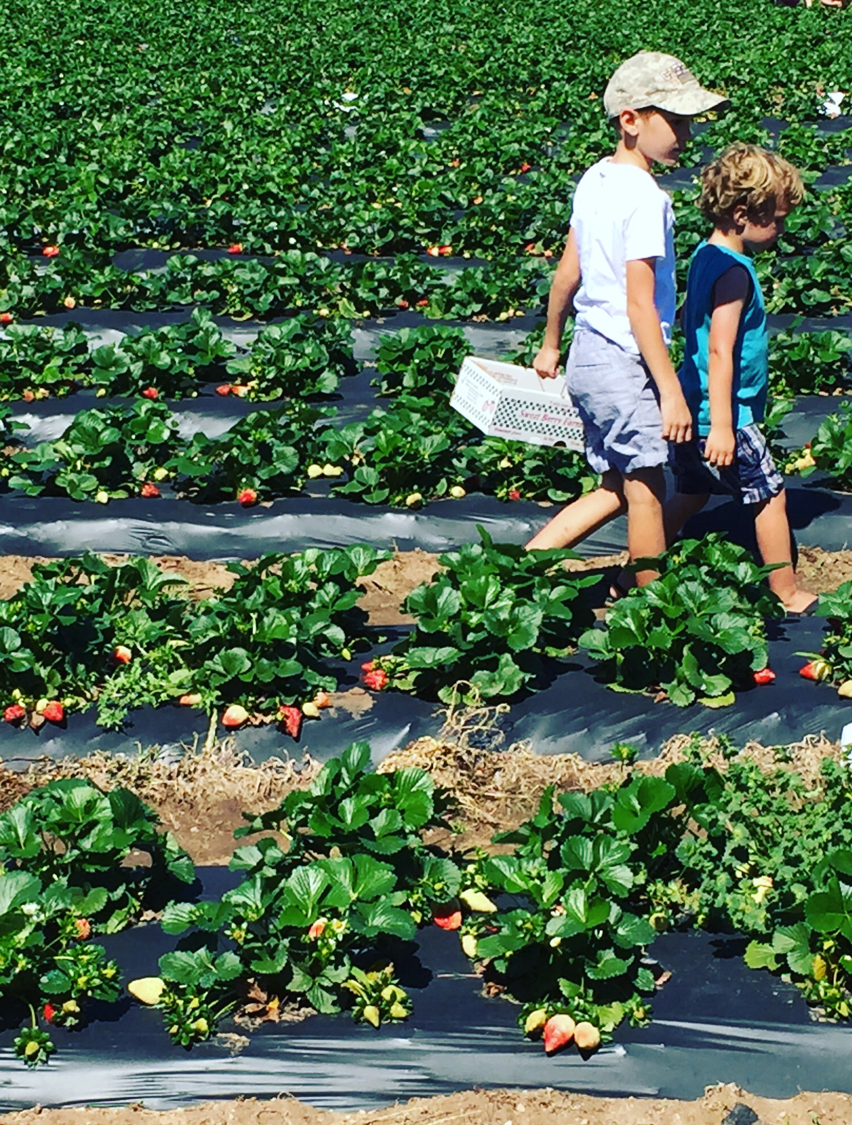
ORGANIC GARDENING SYLLABUS

WEEK 1 – WORMS, COMPOST AND SOIL

PICTURE BOOKS:
Winnie Finn, Worm Farmer
Diary of a Worm
We Dig Worms
The Life Cycle of an Earthworm

CHAPTER BOOKS:
Farmer Boy
Beatrix Potter: The Complete Tales
Poppy
Pilgrim Stories
Among the Farmyard People

OTHER RESOURCES:
Farm Anatomy, pages 12-16
Worms are Wonderful

ACTIVITIES:
Prep beds – add soil, till and prep area for bean teepee
Worm observation jar and release into garden
Make liquid fertilizer, page 17 GROW
Compost project

**Everyday – Water, weed and enjoy garden.
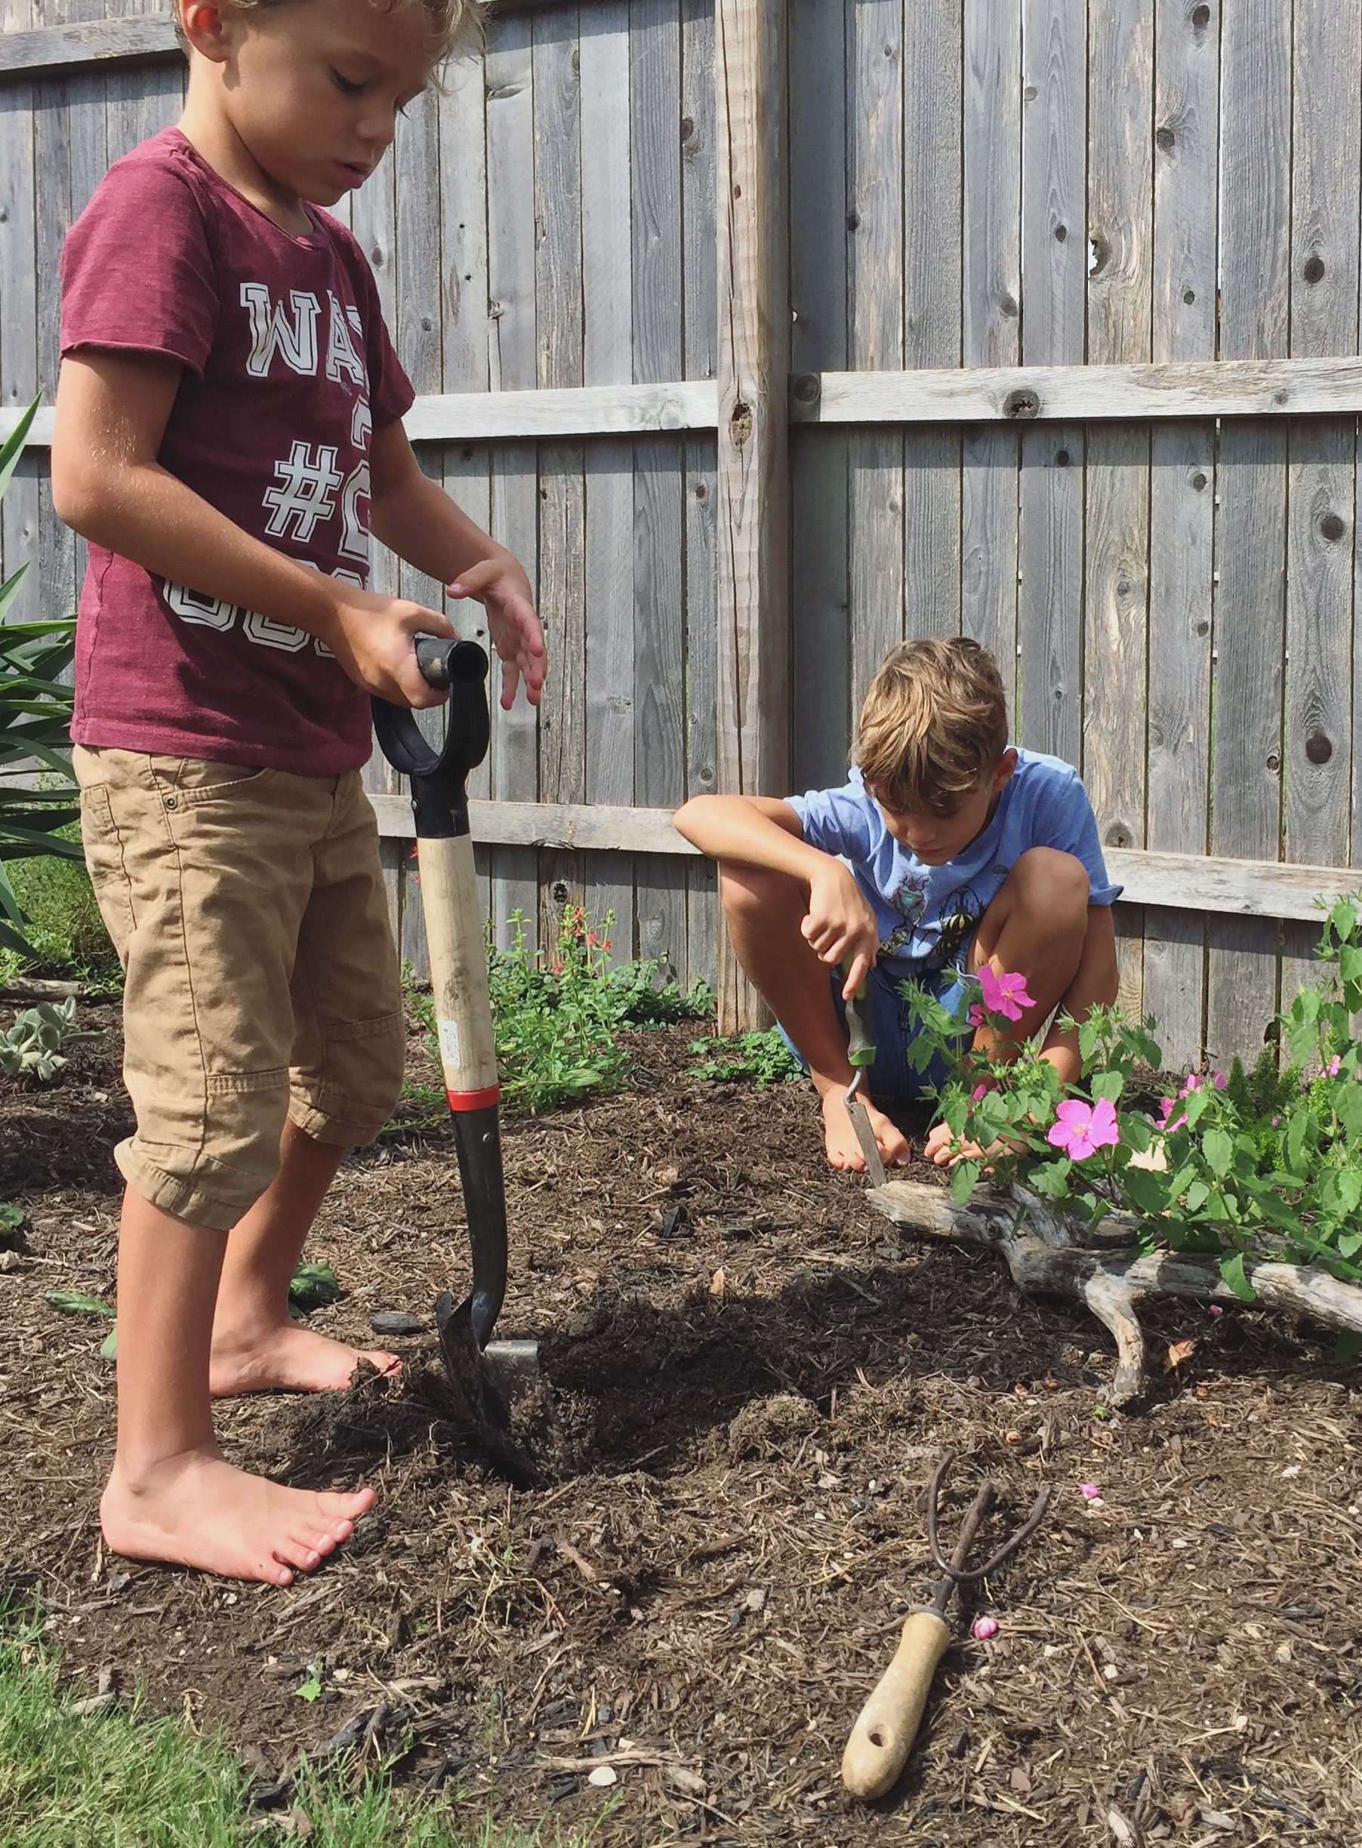
WEEK 2 – GARDEN PLANNING AND PLANTING

PICTURE BOOKS:
How Does My Garden Grow?
Miss Maple’s Seeds
From Seed to Plant
Isabella’s Garden

CHAPTER BOOKS:
Farmer Boy
Beatrix Potter: The Complete Tales
Poppy
Pilgrim Stories
Among the Farmyard People

OTHER RESOURCES:
GROW: A Family Guide to Growing Fruits and Vegetables, pages 28-35
Garden Sheet
Grow Your Own Plants

ACTIVITIES:
Notebook our vegetable garden plot
Plant beans, carrots and cucumbers in beds and cole crop seeds in egg cartons to transplant later

**Everyday – Water, weed and enjoy garden.
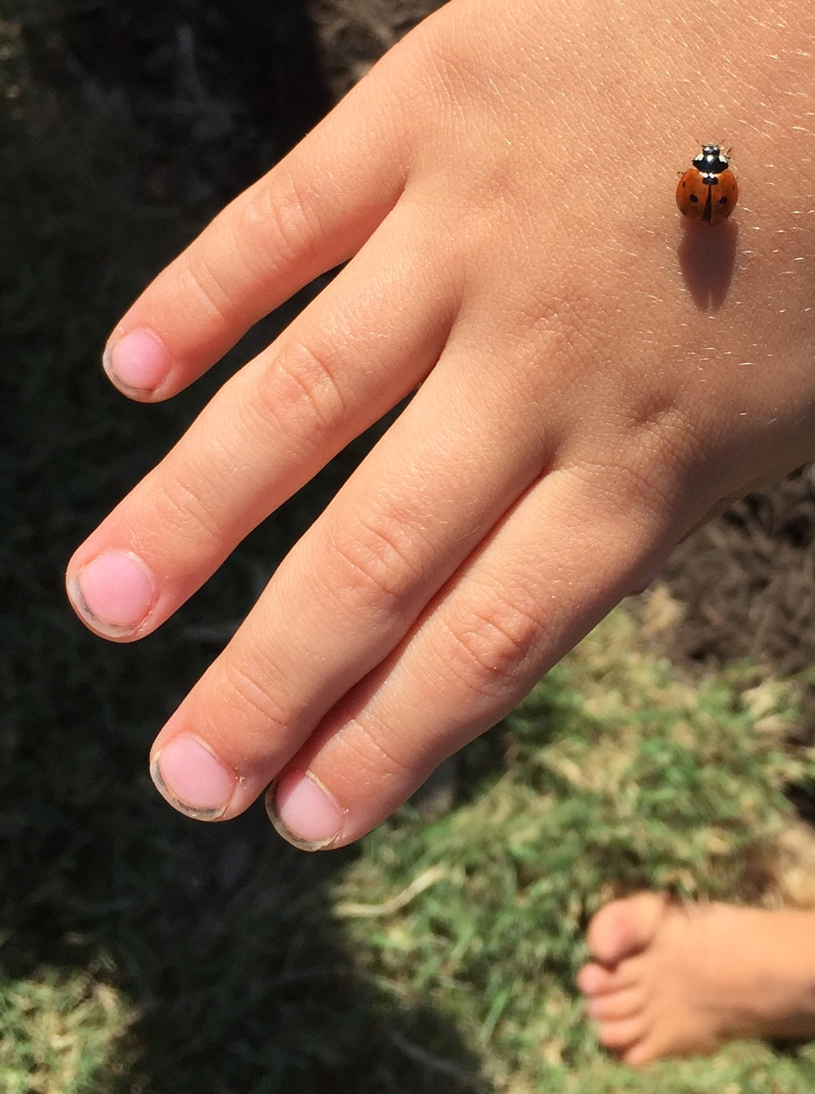
WEEK 3 – BUGS

PICTURE BOOKS:
Ladybugs
Farming
Incredible Bugs
Are You a Ladybug?
The Beetle Book

CHAPTER BOOKS:
Farmer Boy
Beatrix Potter: The Complete Tales
Poppy
Pilgrim Stories
Among the Farmyard People

OTHER RESOURCES:
Farm Anatomy, pages 104-105

ACTIVITIES:
Make plant markers
Tend to seedlings and make observations
Release ladybugs in garden
Notebook vegetable families from How Does My Garden Grow? (may take several weeks to complete)

FIELDTRIPS:
Tour a nearby garden or park to search for bugs and identify.

**Everyday – Water, weed and enjoy garden.
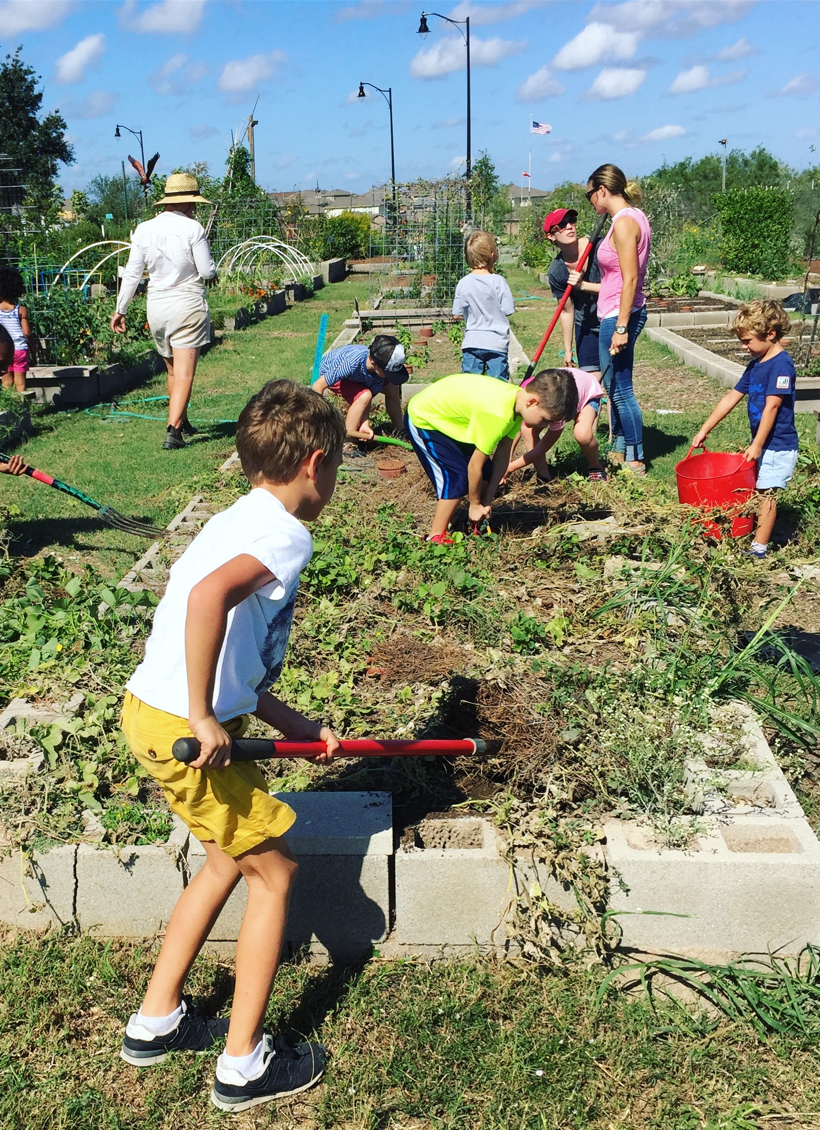
WEEK 4 – LIFE AS A FARMER

PICTURE BOOKS:
Farmer Will Allen and the Growing Table
And the Good Brown Earth
A Weed is a Flower
This Year’s Garden

CHAPTER BOOKS:
Farmer Boy
Beatrix Potter: The Complete Tales
Poppy
Pilgrim Stories
Among the Farmyard People

OTHER RESOURCES:
GROW, page 24

ACTIVITIES:
Discuss what crops and animals you would have if you
owned your own farm
Continue caring for seedlings
Notebook George Washington Carver

FIELDTRIPS:
Visit a local farmer’s market to purchase produce and prepare a meal with it

**Everyday – Water, weed and enjoy garden.
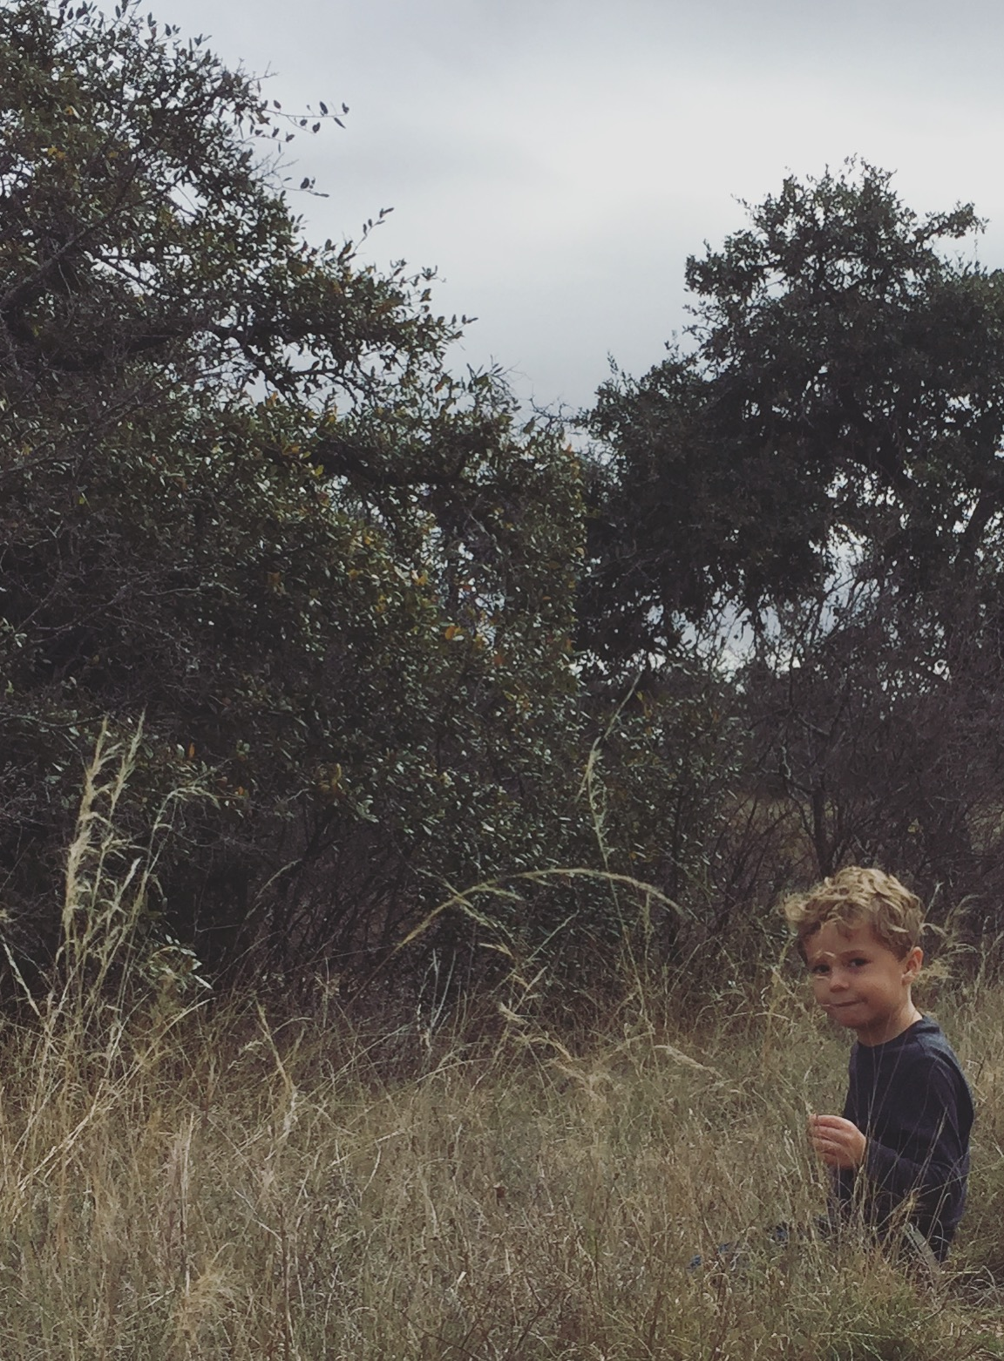
WEEK 5 - GRAINS

PICTURE BOOKS:
The Little Red Hen
Tony’s Bread
The Good Garden
Anywhere Farm

CHAPTER BOOKS:
Farmer Boy
Beatrix Potter: The Complete Tales
Poppy
Pilgrim Stories
Among the Farmyard People

OTHER RESOURCES:
Farm Anatomy, pages 96-101

ACTIVITIES:
Grain activity
Notebook favorite bread recipe and continue working on vegetable families

FIELDTRIPS:
Tour a local farm

**Everyday – Water, weed and enjoy garden.
Week 6 – APPLES

PICTURE BOOKS:
Apples
How Do Apples Grow?
Apples to Oregon
Bring Me Some Apples and I’ll Make you a Pie
Apple Farmer Annie
Johnny Appleseed: The Story of a Legend

CHAPTER BOOKS:
Farmer Boy
Beatrix Potter: The Complete Tales
Poppy
Pilgrim Stories
Among the Farmyard People

OTHER RESOURCES:
Johnny Appleseed video
Farm Anatomy, pages 102-103

ACTIVITIES:
Apple toothpick tower challenge
Make apple butter
Apple prints
Notebook Johnny Appleseed
Apple Life Cycle activity

**Everyday – Water, weed and enjoy garden.
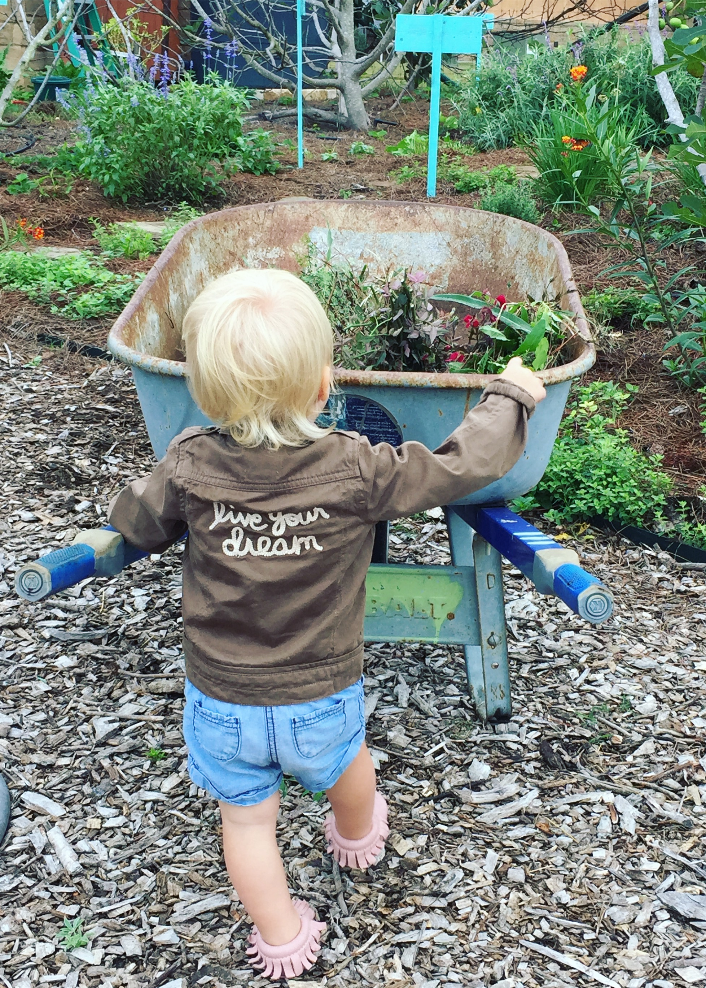
Week 7 – ROOT VEGETABLES PART 1

PICTURE BOOKS:
On the Farm
The Story of the Root Children
Rah, Rah, Radishes
The Vegetables We Eat

CHAPTER BOOKS:
Farmer Boy
Beatrix Potter: The Complete Tales
Poppy
Pilgrim Stories
Among the Farmyard People

OTHER RESOURCES:
Farm Anatomy, page 74

ACTIVITIES:
Harvest radishes
Root Garden Art
Slice radishes and observe
Radish chips
Radish and cucumber salad
Notebook Farmer Boy

**Everyday – Water, weed and enjoy garden.
Week 8 – PUMPKINS AND GOURDS

PICTURE BOOKS:
Pumpkin Jack
Seed, Sprout, Pumpkin, Pie
The Very Best Pumpkin
Apples and Pumpkins

CHAPTER BOOKS:
Farmer Boy
Beatrix Potter: The Complete Tales
Poppy
Pilgrim Stories
Among the Farmyard People

ACTIVITIES:
Roasted pumpkin seeds
Pumpkin pie
Flourless pumpkin brownies
Make gourd birdhouses
Notebook Seed, Sprout, Pumpkin Pie

FIELDTRIPS:
Visit a pumpkin patch

**Everyday – Water, weed and enjoy garden.
Week 9 – CORN

PICTURE BOOKS:
The Popcorn Book
Corn Is Maize: The Gift of the Indians
Corn
People of Corn: A Mayan Story
The Rough-Face Girl

CHAPTER BOOKS:
Farmer Boy
Beatrix Potter: The Complete Tales
Poppy
Pilgrim Stories
Among the Farmyard People

OTHER RESOURCES:
Farm Anatomy, page 83

ACTIVITIES:
Corn kernal necklaces or corn kernel art
Cornbread
Popcorn
Notebook The Rough-Face Girl

FIELDTRIPS:

**Everyday – Water, weed and enjoy garden.
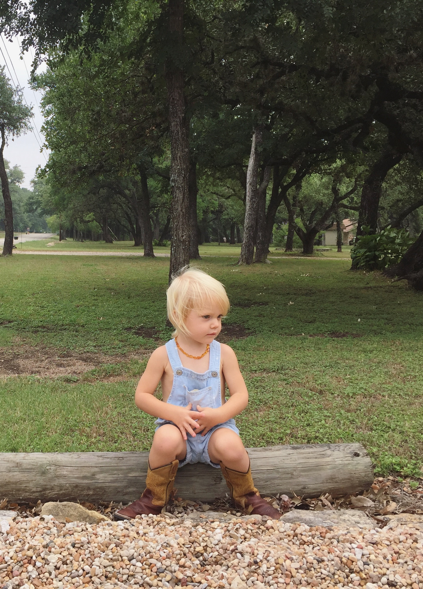
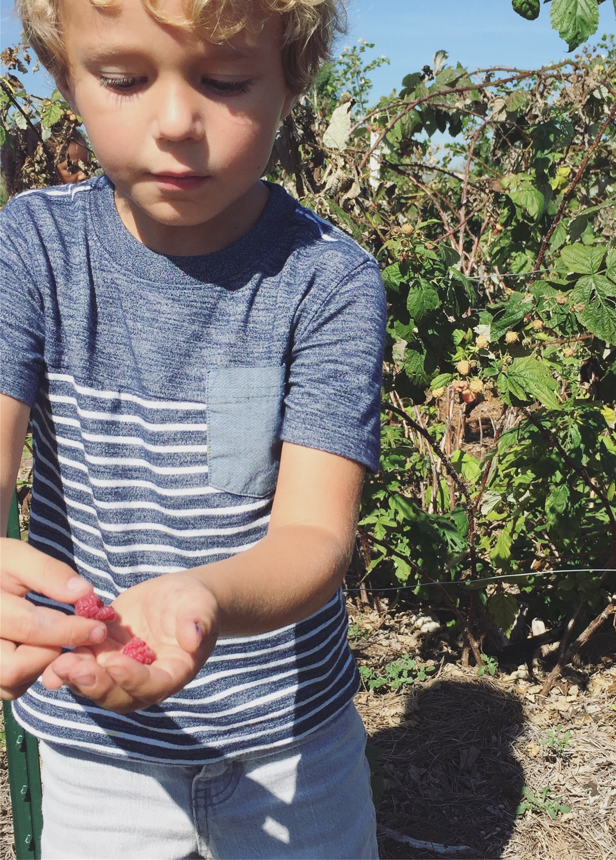
Week 10 – BEANS AND PEAS

PICTURE BOOKS:
Jack and the Beanstalk
Green Beans
Green as a Bean
Little Pea
Gregor Mendel: The Friar Who Grew Peas

CHAPTER BOOKS:
Farmer Boy
Beatrix Potter: The Complete Tales
Poppy
Pilgrim Stories
Among the Farmyard People

OTHER RESOURCES:
Farm Anatomy, pages 78-81
What’s Inside a Bean

ACTIVITIES:
Harvest green beans
Math with Dried Beans
Pickled Dill Green Beans
Can beans
Notebook Gregor Mendel: The Friar Who Grew Peas

**Everyday – Water, weed and enjoy garden.
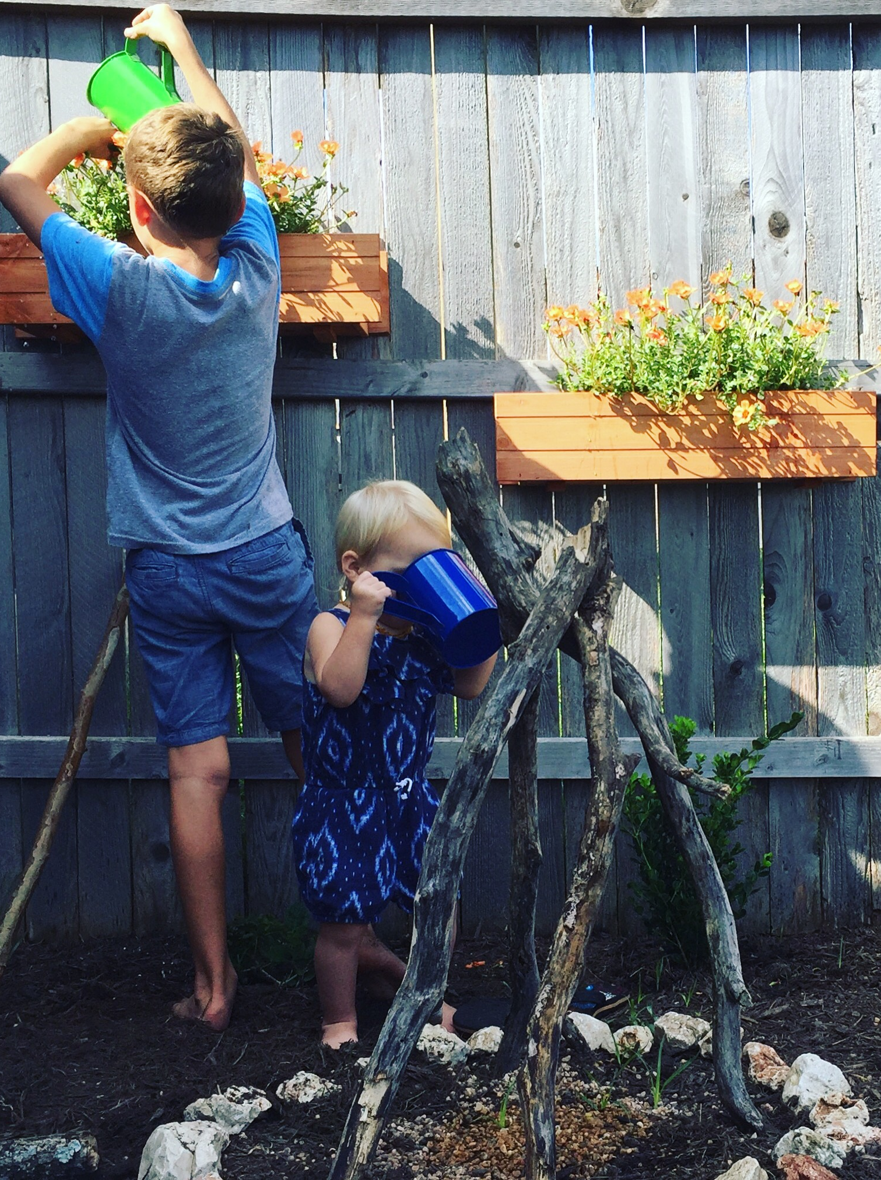
Week 11 – CUCUMBERS

PICTURE BOOKS:
The Year at Maple Hill Farm
Pickles, Please
Pickles to Pittsburgh
Secrets of the Garden: Food Chains and the Food Web in our Backyard

CHAPTER BOOKS:
Farmer Boy
Beatrix Potter: The Complete Tales
Poppy
Pilgrim Stories
Among the Farmyard People

OTHER RESOURCES:
Farm Anatomy, page 75

ACTIVITIES:
Harvest cucumbers
Dill pickles
Cucumber hummus
Notebook Secrets of the Garden

**Everyday – Water, weed and enjoy garden.
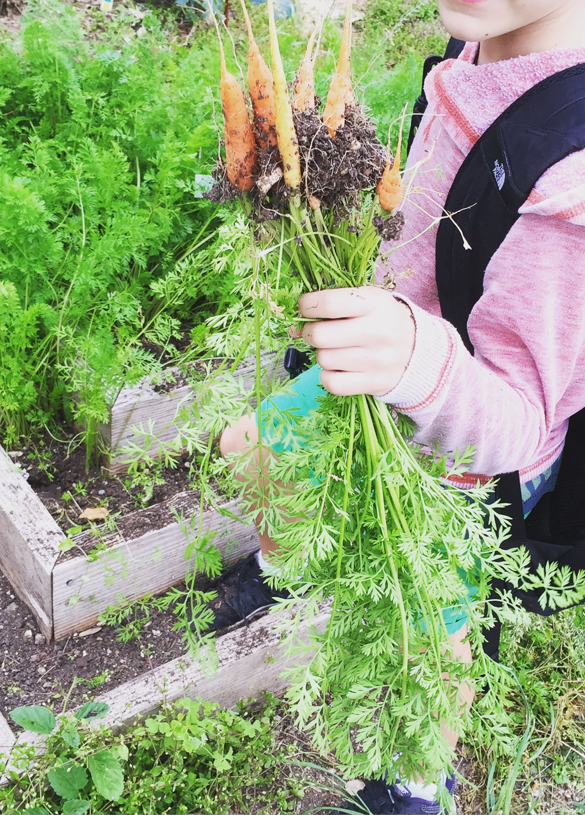
Week 12 – ROOT VEGETABLES PART 2

PICTURE BOOKS:
The Carrot Seed
The Very Big Carrot
One Potato, Two Potato
Too Many Carrots
Rachel Carson and Her Book That Changed the World

CHAPTER BOOKS:
Farmer Boy
Beatrix Potter: The Complete Tales
Poppy
Pilgrim Stories
Among the Farmyard People

OTHER RESOURCES:
Farm Anatomy, pages 87 and 92

ACTIVITIES:
Harvest carrots and potatoes
Grow a carrot top
Grow potato roots in a jar (Wild and Free, Roots Edition)
Carrot cake
Root vegetable narration
Honey Brown Sugar Roasted Carrots
Notebook Rachel Carson

**Everyday – Water, weed and enjoy garden.
Week 13 – COLE PLANTS

PICTURE BOOKS:
The Giant Cabbage
The Cabbage Soup Solution
Who Grew my Soup
Stone Soup

CHAPTER BOOKS:
Farmer Boy
Beatrix Potter: The Complete Tales
Poppy
Pilgrim Stories
Among the Farmyard People

OTHER RESOURCES:
Farm Anatomy, pages 72-74

ACTIVITIES:
Harvest cabbage, kale, broccoli and cauliflower
Italian vegetable beef soup
Slice cabbage and make paint prints
Roasted broccoli
Notebook Pilgrim Stories

**Everyday – Water, weed and enjoy garden.
Week 14 – THANKSGIVING HARVEST

PICTURE BOOKS:
Strega Nona’s Harvest
The Thanksgiving Story
We Gather Together
Giving Thanks: A Native American Good Morning Message

CHAPTER BOOKS:
Farmer Boy
Beatrix Potter: The Complete Tales
Poppy
Pilgrim Stories
Among the Farmyard People

OTHER RESOURCES:
Thanksgiving recipes

ACTIVITIES:
Plan and cook Thanksgiving meal
Discuss all we’re thankful for and write a note thanking someone
Notebook The Thanksgiving Story

**Everyday – Water, weed and enjoy garden.

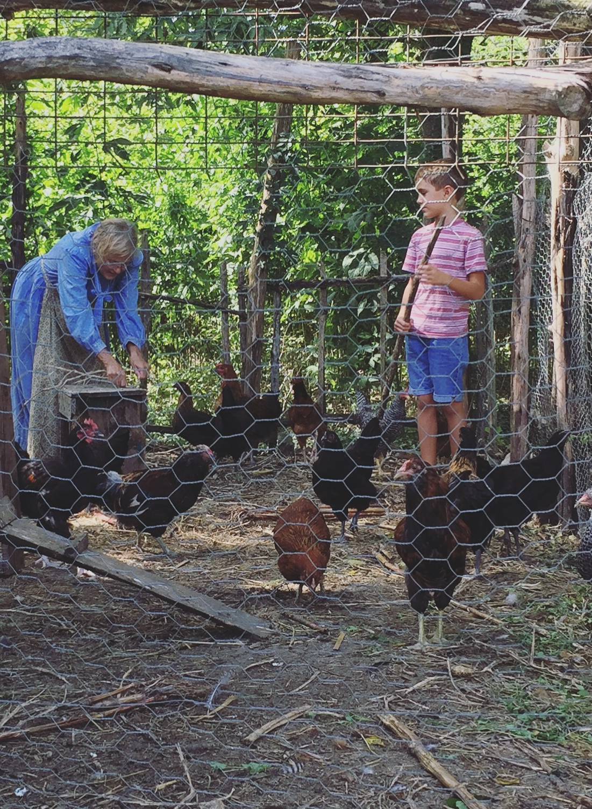
Week 15 – WINTER AND THE WHITE HOUSE

PICTURE BOOKS:
Winter on the Farm
Sleep Tight: A Farm Prepares for Winter
Maple Syrup Season
Diana’s White House Garden
First Garden: The White House Garden and How it Grew

CHAPTER BOOKS:
Farmer Boy
Beatrix Potter: The Complete Tales
Poppy
Pilgrim Stories
Among the Farmyard People

OTHER RESOURCES:
Farm Anatomy, pages 204-205

ACTIVITIES:
Continue harvesting all crops
Kale leaf crowns
Maple Fudge recipe, Farm Anatomy
Notebook garden successes and issues

**Everyday – Water, weed and enjoy garden.

